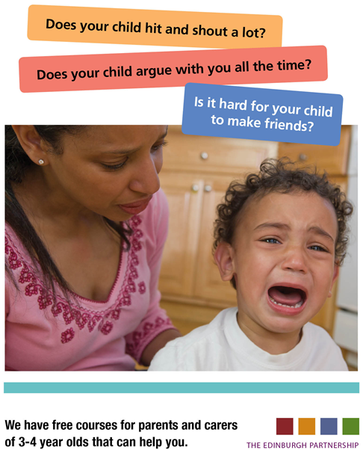

**Since PoPP has been implemented in Edinburgh we have had a huge success delivering 35 groups in various locations across Edinburgh. We are pleased to announce that in Autumn 2016 we are planning to run another 15 Incredible Years and Triple P groups including a pilot of a Primary School age Triple P for parents and carers with children aged 7-11 years. We are accepting applications now. Venues are listed below with dates and times to be confirmed and circulated locally.**

**Incredible Years**  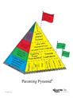

**Royston Wardieburn Community Centre**

**Circle Haven Project - Craigroyston Primary School**

**Brunstane Primary School**

**Dalry Primary School**

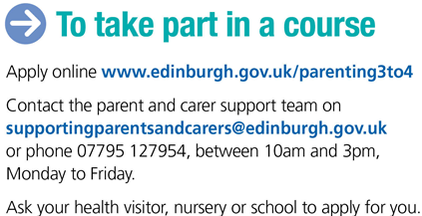

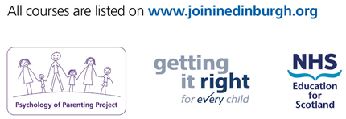

**Gilmerton Community Centre**

**Fox Covert Early Years Centre**

**Greengables Nursery**

**Gylemuir Primary School**

**Viewforth Early Years Centre**

**Wester Hailes Education Centre**

**Rosbery Hall**

**Triple P**  cid:image010.png@01D1A463.E9388CD0

**Dr Bells Family Centre**

**Gate 55**

**Goodtrees Neighbourhood Centre (Primary School age)**

**Greendykes Early Years Centre**