Make a collage demonstrating an extreme weather.  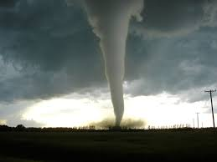 | Investigate how we get clean water to our homes…  You could use a diagram or report to share you findings. | Reading  Create a quiz or an activity for a book you have you have read for the reading challenge.  You could design your own play challenges list.
Create a weather chart to collect information about how the weather changes over 7 days.  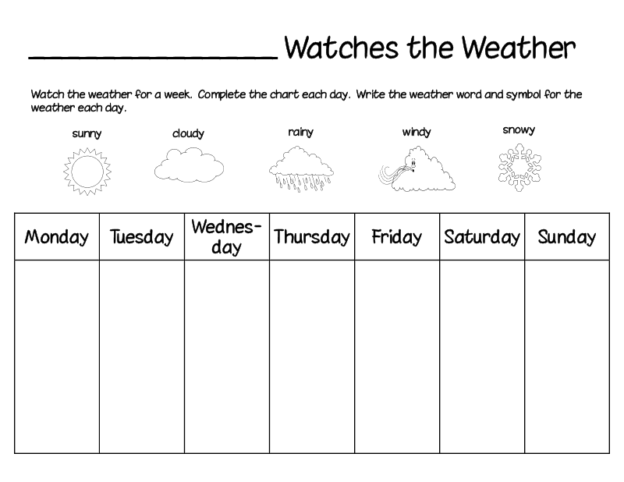 | Write a description about your experience of weather.  A windy day… How did you feel?  A rainy day… What did you see?  What did you hear? | Own choice
Weekly Spelling Task  Please complete 3 bingo activities a week. These should be short, snappy sessions which fit around everyone’s busy schedule. Each week the children will be given 7 words to practise based on a spelling pattern. To extend this you can give them a one minute challenge to think of as many word with that sound as possible. | Weekly Maths & Numeracy Task  For this term we will be using playing cards, which hopefully everyone will have at home. We will stick instructions for each week’s game in the Homelearning jotter. Sumdog maths logins are still active and can be used as often as you like. | Reading  We are setting a reading challenge, alongside the First Minister’s Reading Challenge which is aimed at getting children to love reading no matter what and where they read. Complete the reading around the World Passport where your child will get a stamp for every book they read. Children can borrow a book from our P3 library and this can changed whenever they are finished.
Primary 3 Homelearning Wall

Please choose from the 6 options above to complete your Homelearning wall for this block. Please make at least one choice over the 4 weeks but the bottom row must be completed each week as directed. The other homelearning tasks should be completed by 1st November 2016.

