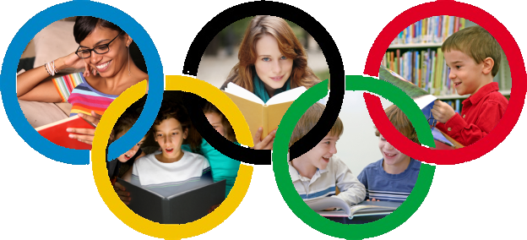

P7 Reading Olympiad
2016/17

During P7, we want to encourage students to read as often and as widely as possible. Reading is a vital skill! It is also important that the children choose their own books and are encouraged to read for enjoyment.

We also want to encourage parents to engage with the Olympiad, both by helping their child to find and read good books, and by reading themselves. If, by Christmas, the class have reached 60, 120 or 250 points – they will receive the bronze, silver or gold class prize.

So take up the challenge – and become a reader! Good luck!

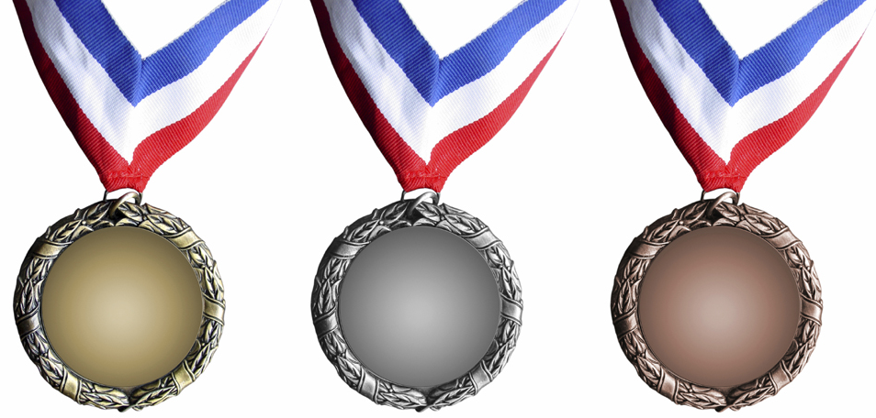
250
120
60

The P7 Reading Olympiad
To encourage frequent reading, we are setting some challenges to P7 students. Every book you read during Primary 7 will earn you one point. To earn additional points, you can complete any of the following challenges:

2 Point Challenges
02
- Read a book someone else has recommended
- Recommend a book that someone else then reads
- Discuss a book with someone else who has read it
- Read a book to someone else (e.g. brother or sister)

3 Point Challenges
03
- Learn a favourite poem by heart
- Read a sequel to a book you’ve already read
- Read a book from the “Recommendations” list
- Read a book from the Key Authors list on page 6
- Read a book and watch the film that goes with it

5 Point Challenges
05
- Read a book from the Top 20 booklist on pages 4 & 5
- Read your parent’s favourite childhood book
- Write a book review
10
10 Point Challenge
- Read a book from the Classics list on page 6

There may also be additional challenges through the year with bonus points awarded.

Top 20 Reading

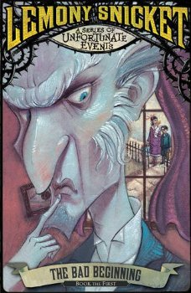 | A Series of Unfortunate Events  By Lemony Snicket  Artemis Fowl  By Eoin Colfer | 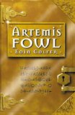
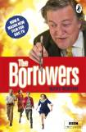 | The Borrowers  By Mary Norton  The Boy in the Striped Pyjamas  By John Boyne | 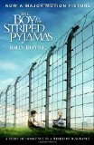
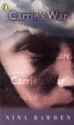 | Carrie’s War  By Nina Bawden  Charlotte’s Web  By E. B. White | 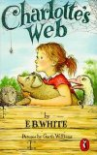
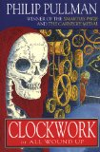 | Clockwork  By Philip Pullman  Cosmic  By Frank Cottrell Boyce | 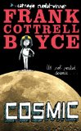
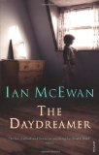 | The Daydreamer  By Ian McEwan  Diary of a Wimpy Kidd  By Jeff Kinnell | 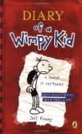
Recommendations

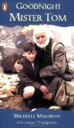 | Goodnight Mister Tom  By Michael Morpurgo  How to Train Your Dragon  By Cressida Cowell | 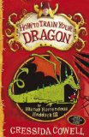
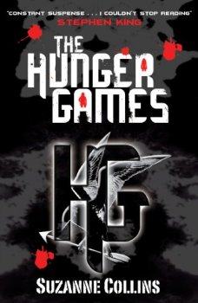 | The Hunger Games  By Suzanne Collins  The Lion, the Witch & the Wardrobe  By C. S. Lewis | 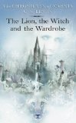
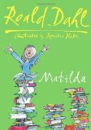 | Matilda  By Roald Dahl  Private Peaceful  By Michael Morpurgo | 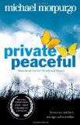
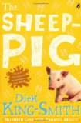 | The Sheep-Pig  By Dick King-Smith  Skelling  By David Almond | 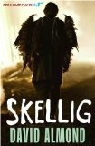
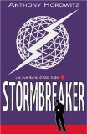 | Stormbreaker  By Anthony Horowitz  There’s a Boy in the Girls’ Bathroom  By Louis Sachar | 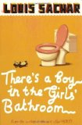
Classics
Why not try something different and go for one of these older ‘classic’ texts? Or one of the recommended authors below?
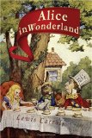 | Alice’s Adventures in Wonderland  By Lewis Caroll  A Christmas Carol  By Charles Dickens | 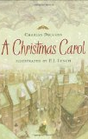
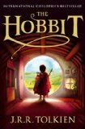 | The Hobbit  By J. R. R. Tokien  I Capture the Castle  By Dodie Smith | 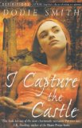
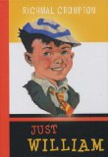 | Just William  By Richmal Crompton  Mary Poppins  By Pamela L. Travers | 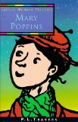
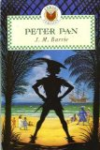 | Peter Pan  By J. M. Barrie  Treasure Island  By Robert Louis Stevenson | 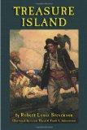
Key Authors

- Malorie Blackman
- Judy Blume
- Roald Dahl
- Anne Fine
- Nigel Hinton
- Chris D’Lacey
- Christopher Edge
- Catherine Macphail
- Anthony Horowitz
- Michael Morpurgo
- Robert Swindells
- Robert Westall
- Jacqueline Wilson

What else can we do?

There are lots of things that families can do together to support the improvement of reading ability and enjoyment – and not all of them require a book!

Talk as a family about reading
By P7 most students are competent readers and are less likely to read aloud to an adult. That’s a natural progression, but it doesn’t mean that parents don’t have a part to play. The higher level skills of inference and understanding the craft of an author can be supported by talking about what has been read.

Share a book
Just because you don’t necessarily read together doesn’t mean that parents and children can’t share a book. Young Adult fiction is excellent and well worth a read as a parent. Why not both read the same book?

Model what it is to be a reader
Many parents will read, whether it be fiction, newspapers, online or in any other context. Get in the habit of being seen to read, and valuing reading.

Join the library – and visit!
Library membership is free.

Good & Bad Reading

Fiction books aren’t the only sort of reading material that will help you improve your reading ability.

Reading these will help:
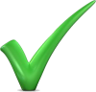  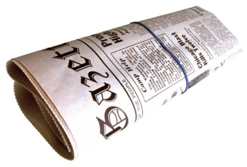 | 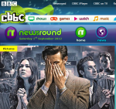 | 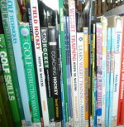
Newspapers | Websites | Non-fiction
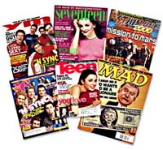 | 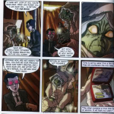 | 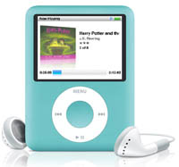
Magazines | Graphic Novels | Audio books

Reading these won’t:
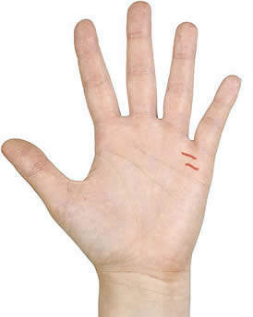 | 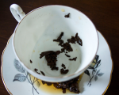
Palms | Tea Leaves

