Primary 3 - 4 Homelearning Wall
Create a postcard of somewhere in Scotland.  Write a message to your teacher as if you have been to visit it. Let us know what there is to do.  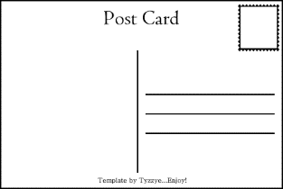 | Learn the Scottish poem Street Talk by JK Annand.  We will be reciting this in school.  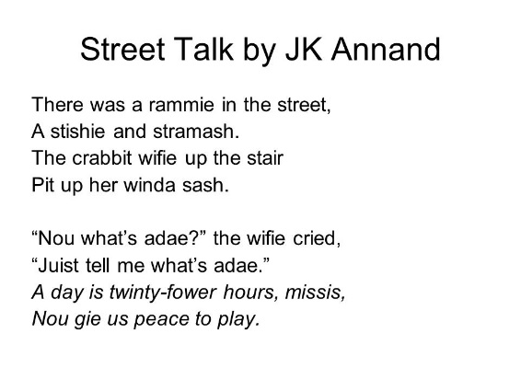 | Reading  Read a Scottish story, eg Katie Morag  Create a story map of what you have read. 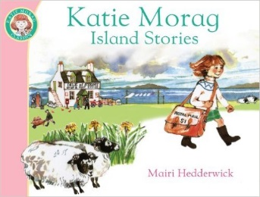 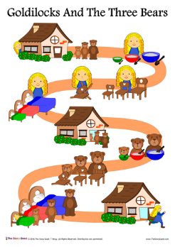
Visit a Scottish monument or landmark. Create a Fact file about it to show the information you have found out. | Find out what happens at a Burns Supper.  You can decide how you share this information. It could be a poster or invitation that you create. | Own choice
Weekly Spelling Task  Please complete 3 bingo activities a week. These should be short, snappy sessions which fit around everyone’s busy schedule. Each week the children will be given 7 words to practise based on a spelling pattern. To extend this you can give them a one minute challenge to think of as many word with that sound as possible. | Weekly Maths & Numeracy Task  For this term we will be using playing cards, which hopefully everyone will have at home. We will stick instructions for each week’s game in the Homelearning jotter. Sumdog maths logins are still active and can be used as often as you like. | Reading  We are setting a reading challenge, alongside the First Minister’s Reading Challenge which is aimed at getting children to love reading no matter what and where they read. Children can borrow a book from our P3 library and this can changed whenever they are finished.

Please choose from the 6 options above to complete your Homelearning wall for this block. Please make at least one choice over the 4 weeks but the bottom row must be completed each week as directed. The other homelearning tasks should be completed by 28th February 2017.

