13-17th Movember 2017
My Learning Week in Primary 6 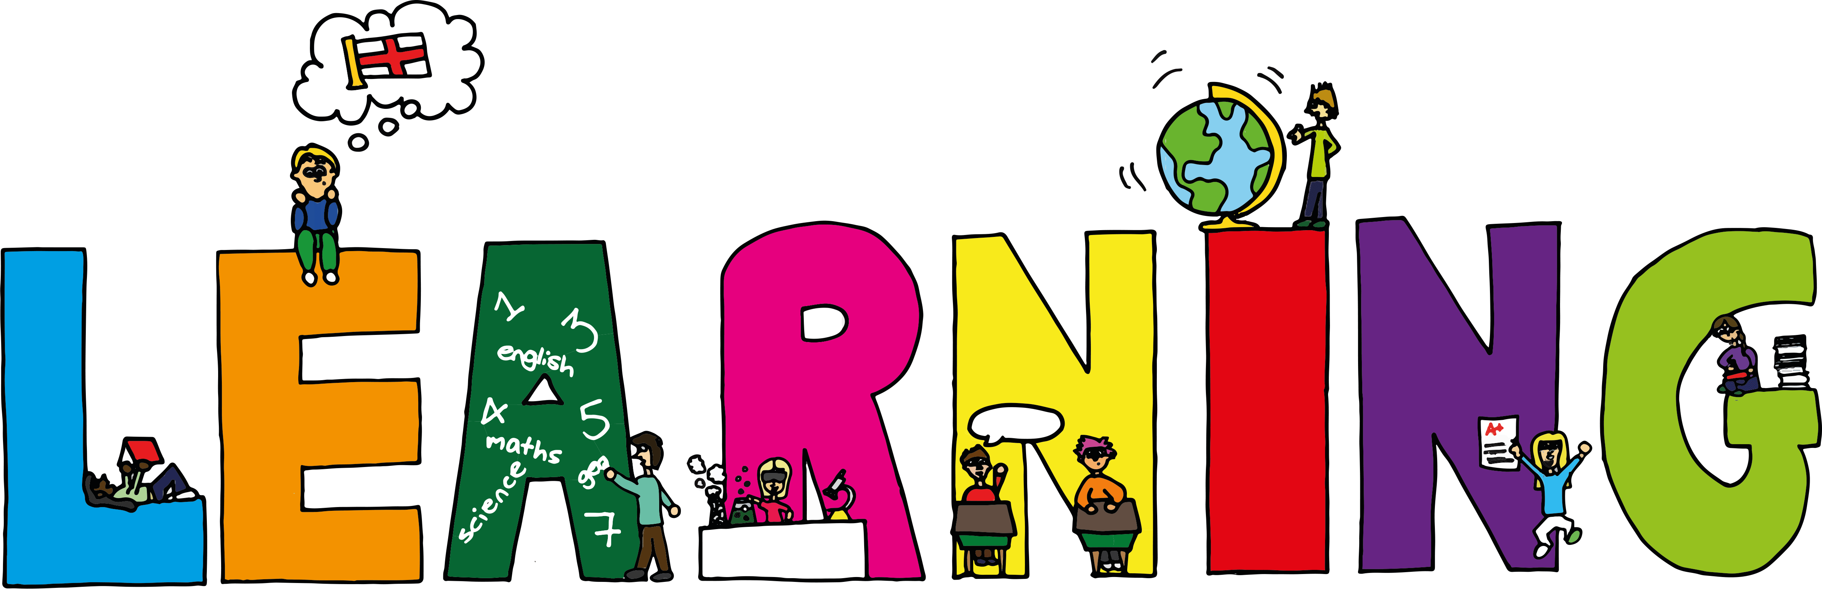
Literacy | Reading | Numeracy: Big maths
Spelling  I can spell words that end in ‘et’ correctly  VCOP  I can explain how and when to use speech marks correctly. | I can explain the strategies I can use to help me when I get stuck reading.  I can retell the main parts of the story I have read. | Count Fourways  I can count forwards and backwards in steps of 0.2.  Multiplication  I can multiply 2 digit numbers by 1, 2 and 3 digit numbers  Division  I can use smile multiplication to find a division fact
Modern Languages  French  I can read, write and count numbers to 100.  I can read and say the days of the week.  ----------------------------------  Art  I can design anti bullying posters in a graffiti themed style. | Health and Wellbeing-P.E | Social Studies/Science
 | Possession Games- Rugby  I can pass and catch a rugby ball using the correct technique.  Anti-Bullying Week  I can name strategies to deal with bullying behaviour.  I can suggest ways to help others who are being affected by bullying. | Sources of energy  I can explain the difference between renewable and non-renewable sources of energy.  I can research different forms of renewable energy and find out how they work and the advantages and disadvantages of each.

