15-19th January 2018
My Learning Week in Primary 6 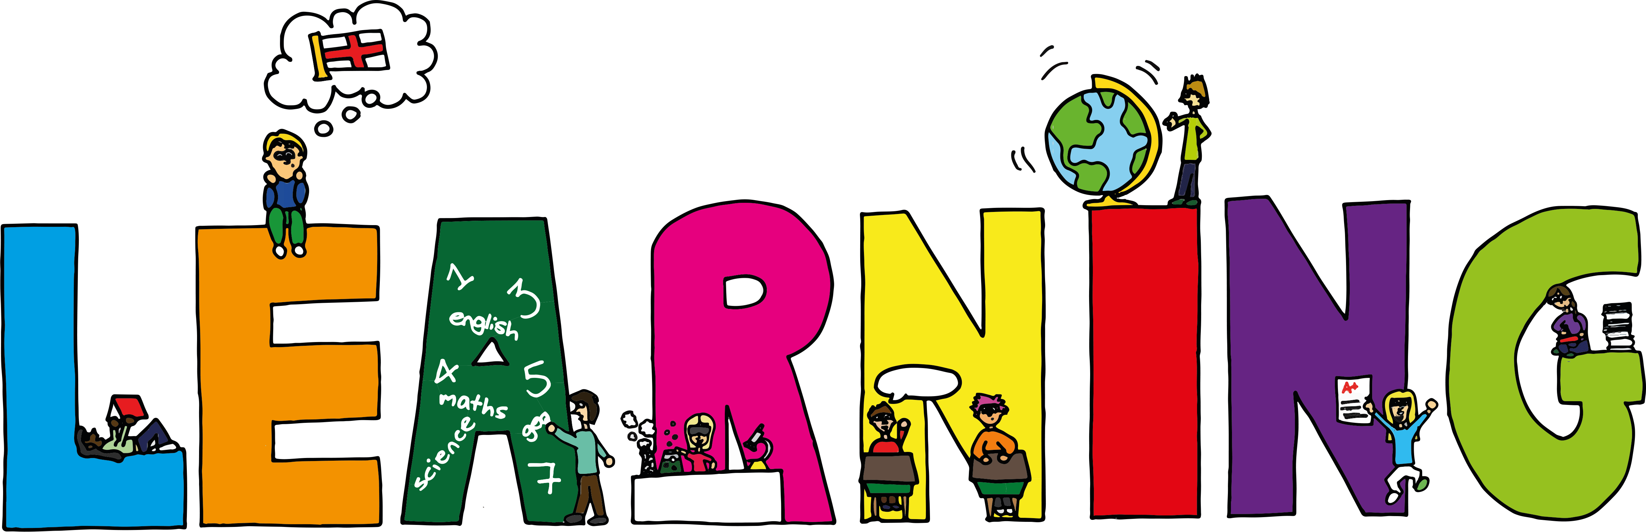
Literacy | Reading | Numeracy:
Spelling  I can spell words that end in ‘en’ and ‘on’ correctly.  VCOP-Metaphors and Similes  I can understand the difference between metaphors and similes and write my own to describe feelings and settings. | I can read and interpret a traditional Scottish poem written by Robbie Burns. | Data Handling  I can interpret and explain information displayed on different types of graphs (column, picture and pie graphs)  I can accurately draw and label different types of graphs.
The Arts  I can learn and perform a traditional Scottish song.  I can create a piece of artwork based on a Scottish Artist. | Health and Wellbeing-P.E | Social Studies-Scotland
 | Volleyball  I can explain some of the rules in volleyball. I can use the proper technique to hit the ball accurately.  I can support and encourage my teammates and opponents. | Geography  I can complete a map of Scotland by adding the main cities, towns and main landmark.  History  I can learn and research information about six key historical figures in Scottish history.

