19-23 February 2018
My Learning Week in Primary 6 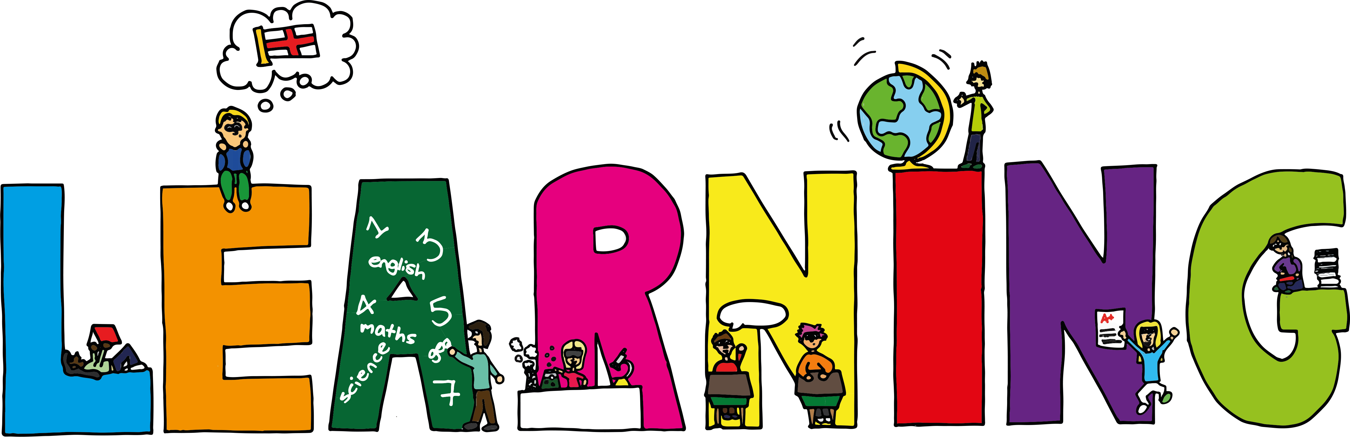
Literacy | Reading | Numeracy:
Spelling  I can spell words that contain the soft ‘g’ sound correctly.  VCOP  Vocabulary-I can find and use persuasive and emotive words to use in my writing.  Writing  I can take notes and write a persuasive piece of writing about why my European country is so interesting. | I can explain the strategies  I can use to help me when I get stuck reading.  I can retell the main parts of the story I have read. | Data Handling  Fractions  I can identify equivalent fractions  I can find the fraction amount of a set  Big Maths  I can understand square numbers.
Science  Fish in the Classroom  I can care for the trout eggs in our classroom by keeping the tank at the right temperature and removing dead eggs.  I can complete my ‘Fish in the classroom’ workbook and answer questions about the lifecycle of the trout. | Health and Wellbeing-P.E | Social Studies-Europe
 | .  I can support and encourage my teammates and opponents.  I can use the correct technique to catch, throw and hit a ball in cricket. | Country Study  I can work as a team to research facts about a European country.  I can take notes and sort information from a range of different sources.

