20-24th Movember 2017
My Learning Week in Primary 6 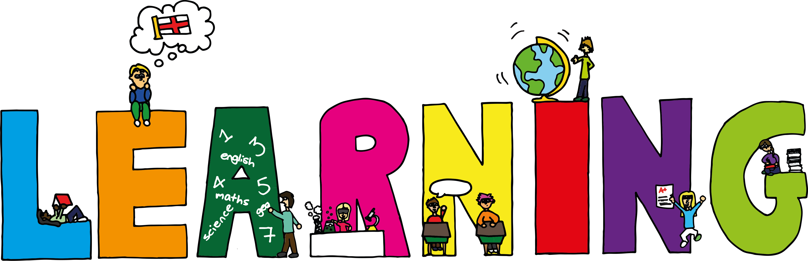
Literacy | Reading | Numeracy: Big maths
Spelling  I can spell words that have the letters ‘qu’ in them.  VCOP-Connectives  I can choose the most appropriate connective to join two simple sentences together.  Persuasive Writing  I can compare coal and wind as a power source and form my own opinion on which I think is best. | I can explain the strategies I can use to help me when I get stuck reading.  I can retell the main parts of the story I have read. | Count Fourways  I can count forwards and backwards in steps of 0.2.  It’s Nothing New  I can do smile multiplication for tenths  Division  I can use smile multiplication to find a division fact  I can solve division problems that have remainders
Modern Languages  French  I can read, write and count numbers to 100.  I can read and say the days of the week. | Health and Wellbeing-P.E | Social Studies/Science
 | Possession Games- Netball  I can pass, catch and shoot a netball using the correct technique.  I can explain some of the rules of netball to others. | Sources of energy  I can research different forms of renewable energy and find out how they work and the advantages and disadvantages of each.  I can design, make and test a wind turbine.

