27th Movember-1st December 2017
My Learning Week in Primary 6 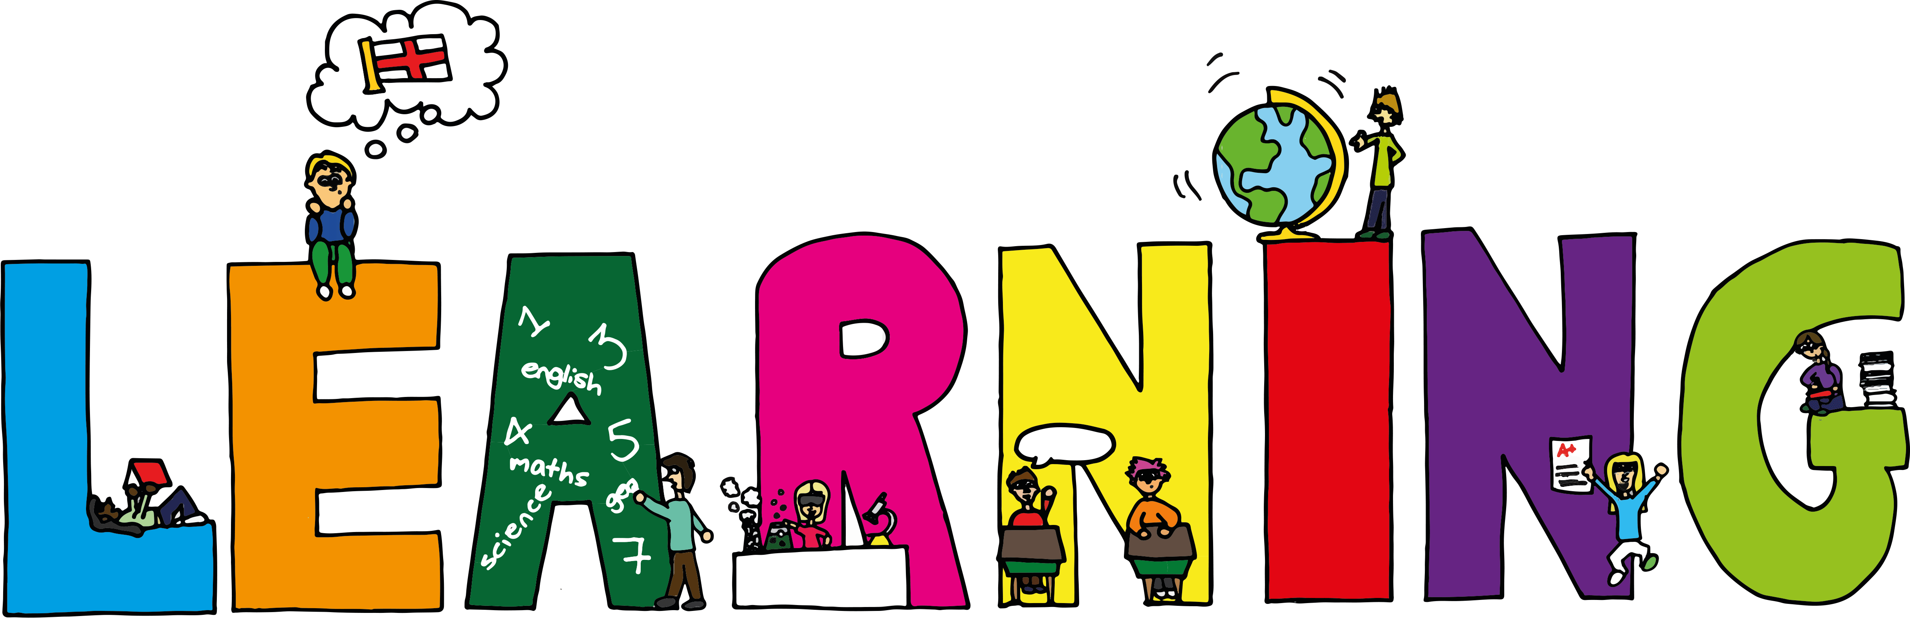
Literacy | Reading | Numeracy: Big maths
Spelling  I can spell words that end in ‘ow’.  VCOP-Connectives  I can choose the most appropriate connective to join two simple sentences together.  Persuasive/Report Writing  I can write a report explaining why it is important to save power and ways in which we can reduce the amount of energy we use. | Book Week  STOP, DROP and READ  I can design a book cover for one of my favourite books.  I can write a book review about a book I have recently read. | Count Fourways  I can count forwards and backwards in steps of 0.2.  It’s Nothing New  I can do smile multiplication for tenths  I can half any 3d number  Division  I can solve division problems that have remainders
Modern Languages  French  I can read, write and count numbers to 100.  I can explain how the weather is in French. | Health and Wellbeing-P.E | Social Studies/Science
 | Possession Games- Netball  I can pass, catch and shoot a netball using the correct technique.  I can explain some of the rules of netball to others. | Sources of energy  I can explain why we need to save power and suggest different ways that we can reduce the amount of energy we use.  I can invent and design my own ‘funky’ renewable energy source.

