29-2 Feb January 2018
My Learning Week in Primary 6 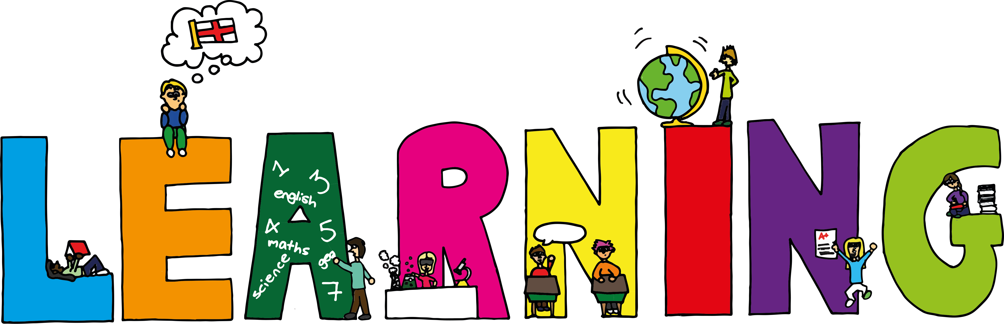
Literacy | Reading | Numeracy:
Spelling  I can spell words that contain the soft ‘c’ sound correctly.  VCOP-Metaphors and Similes  I can understand the difference between metaphors and similes and write my own to describe feelings and settings. | I can explain the strategies  I can use to help me when I get stuck reading.  I can retell the main parts of the story I have read. | Data Handling  I can divide decimals by 100.  I can solve any 1d.1dp + 1d.1dp  I can solve 2d x 3d using coin multiplication
Science  Fish in the Classroom  I can care for the trout eggs in our classroom by keeping the tank at the right temperature and removing dead eggs.  I can complete my ‘Fish in the classroom’ workbook and answer questions about the lifecycle of the trout. | Health and Wellbeing-P.E | Social Studies-Europe
 | I can explain what stamina is and why it is important when playing sport.  I can participate in a range of fitness activities to access my own stamina.  I can support and encourage my teammates and opponents. | The Mystery of the Golden Stars  I can explain when and who first decided that Britain should join the EU.  I can explain the meaning of the symbolism of the stars in the flag for the EU.

