30 April-4 May 2018
My Learning Week in Primary 6 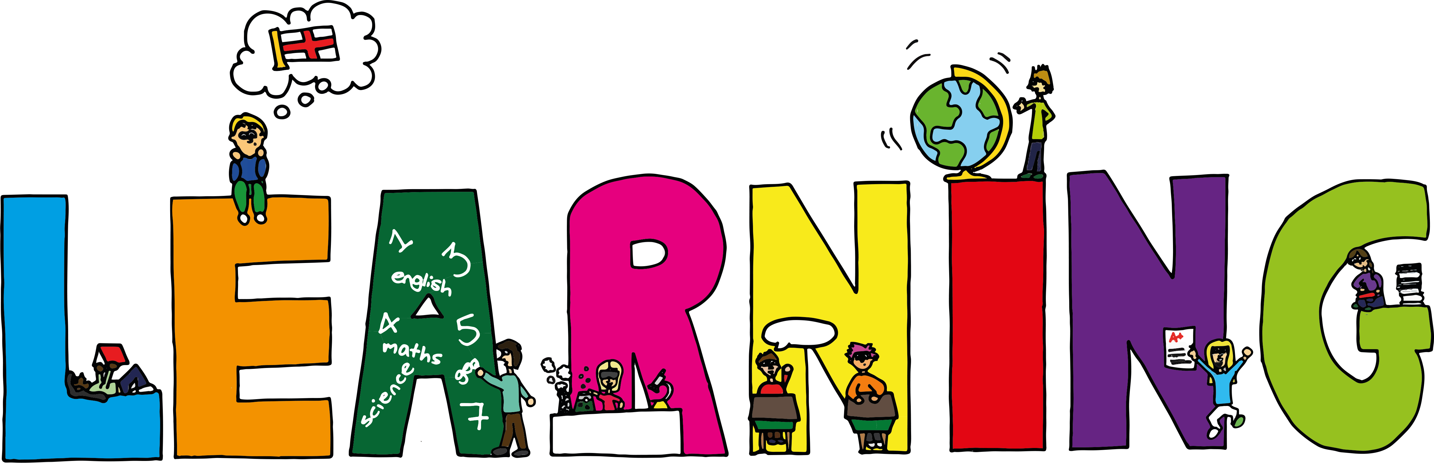
Literacy | Reading | Numeracy:
Spelling  I can spell words that begin with the prefix dis.  Writing-Poetry  I can learn the rules of writing a Diamante poem and then write my own.  VCOP/Grammar  Apostrophes-I can explain the main users of apostrophes in writing. | I can explain the strategies  I can use to help me when I get stuck reading.  I can retell the main parts of the story I have read. | Addition/Subtraction Column Methods  I can use the column method to solve addition and subtraction problems.  Money
Modern Languages -French |  | Health and Wellbeing
 | Athletics  I can participate in a range of different athletic events using the correct techniques.  I can support and encourage my peers. | Keeping Myself Safe  I can explain the difference between ok and inappropriate touch.  I can identify early warning signs and strategies to keep myself safe.
The Arts
I can design a poster to show why I love Cramond.

