2017 30th October-3rd Movember
My Learning Week in Primary 6 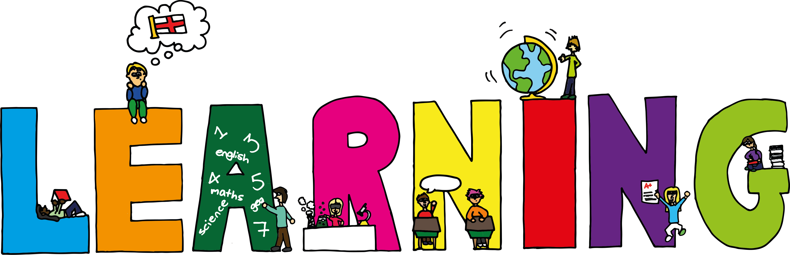
Literacy | Reading | Numeracy: Big maths
Spelling  I can spell words which have the silent w’s in them  VCOP  I can explain how and when to use speech marks correctly. | I can explain the strategies I can use to help me when I get stuck reading.  I can retell the main parts of the story I have read. | Time  I can tell the time using digital and analogue clocks.  I can use a number line to work out elapsed time.  I can convert am/pm time to 24hr time.
RME | Health and Wellbeing-P.E | Social Studies/Science
Hinduism  I can explain what Diwali is and how and why it is celebrated?  I can design and draw my own Rangoli patterns. | Possession Games- Rugby  I can try my hardest learn new skills and techniques.  I can support others and show good sportsmanship.  I can pass and catch a rugby ball using the correct technique. | Sources of energy  I can explain the difference between renewable and non-renewable sources of energy.  I can research different forms of renewable energy and find out how they work and the advantages and disadvantages of each.
Modern Languages
French
I can read, write and count numbers to 100.

