4-8th June 2018
My Learning Week in Primary 6 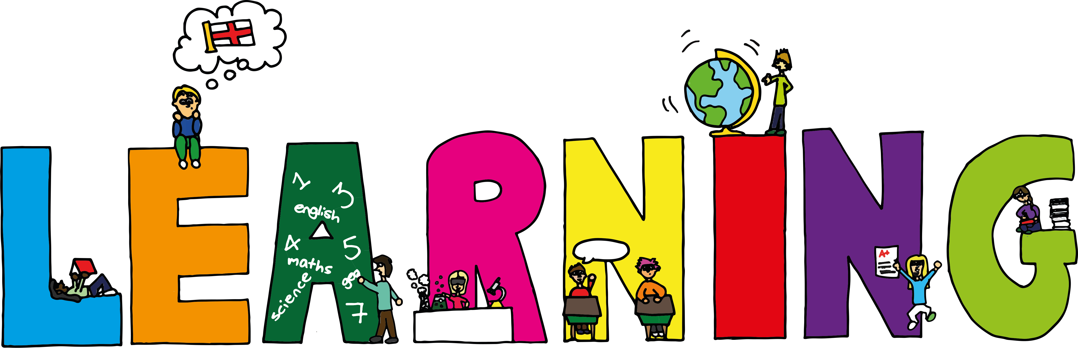
Literacy | Reading | Numeracy
Spelling  I can spell words that end in ‘ey’.  Writing  I can describe a character by ‘showing not telling’ the reader.  VCOP/Grammar  Clauses- I can use the words who, which, where and whose to add a clause to my sentence. | I can explain the strategies  I can use to help me when I get stuck reading.  I can learn lines and perform a play to the class using expression. | Division  I can solve division problems using coin multiplication.  I can partition a 3dp number
Modern Languages -French | Science | RME
I can name the different parts of the body/clothing in French | I can explain what ‘forces’ are and how to measure them.  I can explain what friction is and how is can be useful and harmful. | I can explain the similarities and differences between creation stories from other religions/cultures.

