4-8th December 2017
My Learning Week in Primary 6 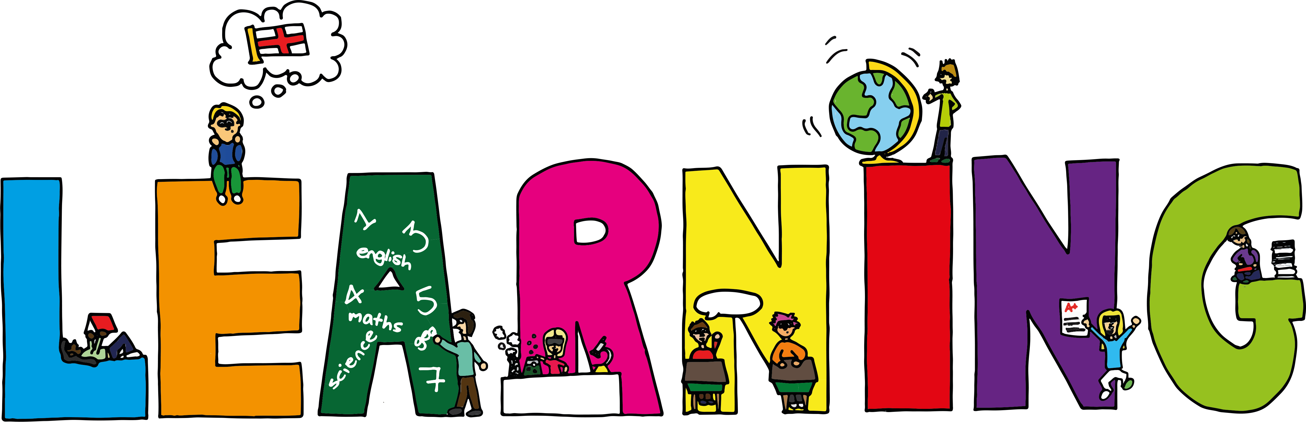
Literacy | Reading | Numeracy: Big maths
Spelling  I can spell words that end in ‘ow’.  VCOP-Connectives  I can choose the most appropriate connective to join two simple sentences together.  Letter Writing  I can write a letter explaining how my invention is able to solve an existing problem. | I can summarise the main parts of the text I have read.  I can use clues in the text to solve the meanings of unknown words  I can use the clues in the text to make an inference (smart guess) | Count Fourways  I can count forwards and backwards in steps of 0.2.  It’s Nothing New  I can do smile multiplication for tenths  I can half any 3d number  Division  I can solve division problems that have remainders
Modern Languages  French  I can read, write and count numbers to 100.  I can explain how the weather is in French. | Health and Wellbeing-P.E | Social Studies/Science
 | Scottish Country Dancing  I can learn and dance a variety of Scottish dances.  _____________________  Art  I can use tissue paper to create a winter picture. | Sources of energy  I can explain why we need to save power and suggest different ways that we can reduce the amount of energy we use.  I can invent and design my own ‘funky’ renewable energy source.

