6-10th Movember 2017
My Learning Week in Primary 6 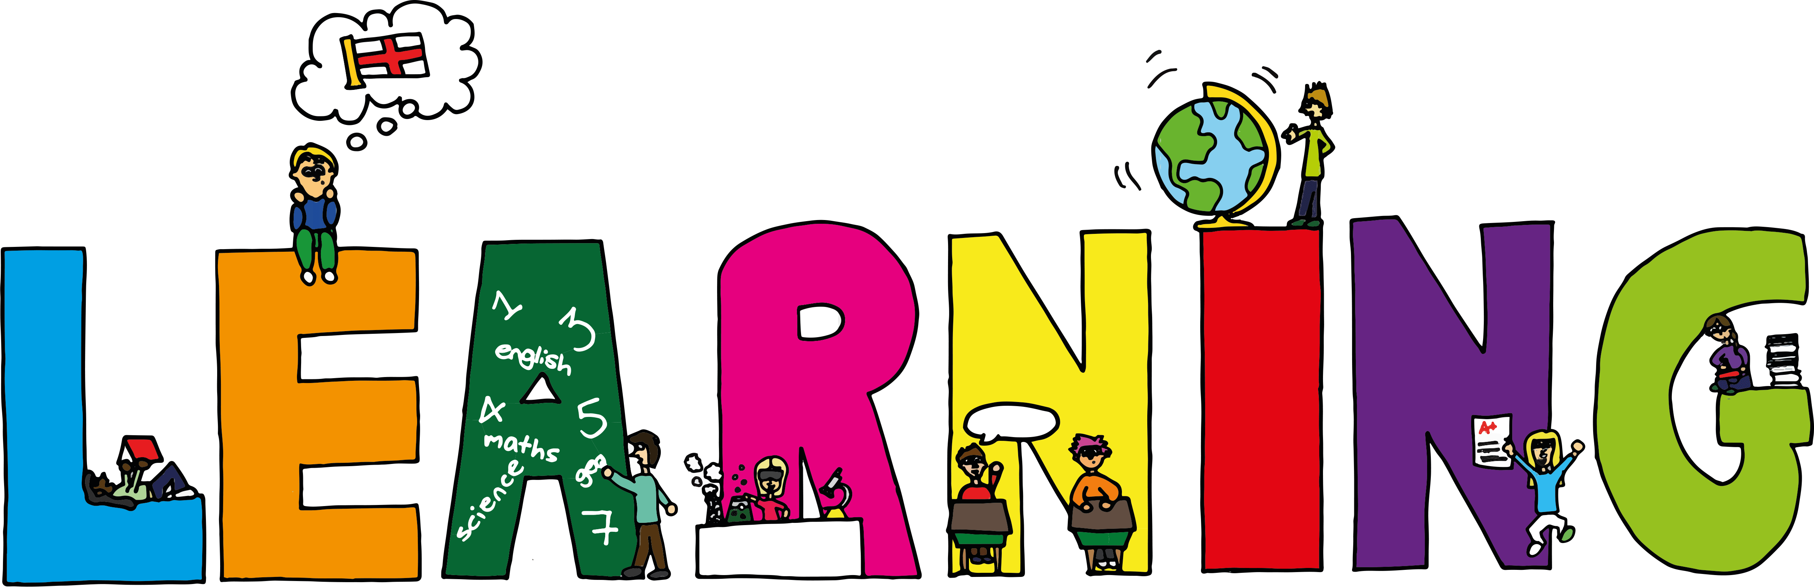
Literacy | Reading | Numeracy: Big maths
Spelling  I can spell words that end in ‘et’ correctly  VCOP  I can explain how and when to use speech marks correctly.  Information Report Writing  I can write an information report about renewable and non-renewable energy. I can research information from a range of sources to aid in writing my report. | I can explain the strategies I can use to help me when I get stuck reading.  I can retell the main parts of the story I have read.
Modern Languages  French  I can read, write and count numbers to 100. | Health and Wellbeing-P.E | Social Studies/Science
 | Possession Games- Rugby  I can try my hardest learn new skills and techniques.  I can support others and show good sportsmanship.  I can pass and catch a rugby ball using the correct technique. | Sources of energy  I can explain the difference between renewable and non-renewable sources of energy.  I can research different forms of renewable energy and find out how they work and the advantages and disadvantages of each.

