17-20 April 2018
My Learning Week in Primary 6 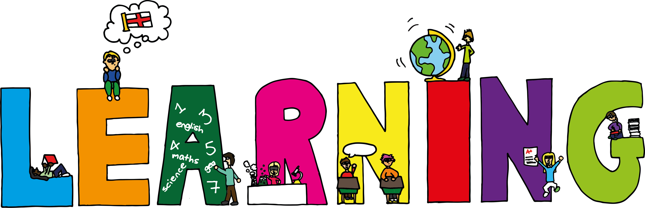
Literacy | Reading | Numeracy:
Spelling  I can spell words that have ‘ei’ in them correctly.  Writing-Poetry  I can learn the rules of writing a Diamante poem and then write my own.  VCOP/Grammar  Apostrophes-I can explain the main users of apostrophes in writing. | I can explain the strategies  I can use to help me when I get stuck reading.  I can retell the main parts of the story I have read. | Addition Column Methods  I can use the column method to solve addition problems.  Big Maths  I can find Mully using smile and coin multiplication.
 | The Arts/RME | Health

