September 2017 October 24-27
My Learning Week in Primary 6 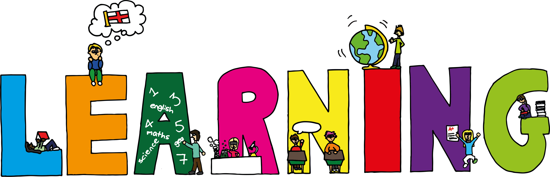
Literacy | Reading | Numeracy: Big maths
Spelling  I can spell words which have the letters ‘ull’ in them  VCOP  I can explain how and when to use capital letters correctly | I can explain the strategies I can use to help me when I get stuck reading.  I can retell the main parts of the story I have read. | Time  I can tell the time using digital and analogue clocks.  I can use a number line to work out elapsed time.  I can convert am/pm time to 24hr time.
RME | Health and Wellbeing-P.E | Modern Languages
Creation Stories  I can research a religion of my choice and present my findings to others. | Possession Games-Rugby  I can try my hardest learn new skills and techniques.  I can support others and show good sportsmanship.  I can pass and catch a rugby ball using the correct technique. | French  I can greet others in French. I can ask and tell others my name and age.

