Primary 6 Homework Wall
Please make sure that you submit at least 4 tasks by Monday 23rd October .

Modern Languages  Write a shopping list of ten items you would like to buy from the supermarket in German. | Country Study- Scotland  Go onto the P6 blog and open up the country study post. Answer the questions about Scotland-either in your homework jotter or make a booklet/poster. | Technology/S.T.E.M  Make your own amazing 3d projection, simply by using your smartphone and a sheet of plastic.  http://www.instructables.com/id/Amazing-3D-Projection-Pyramid-in-10-min-from-Clear/ | Maths  Power Line Challenge  Google-Power Lines Primary Games.  What’s the highest level that you can reach?  (Miss Barr can get up to level 10!)  Your Level ________
Handwriting  Copy out the handwriting on the lines, exactly as it is on the sheet. Join your letters in the same places.  Ask Mr Powell or Miss Barr for a handwriting sheet. | Expressive Arts  Design and make a space rocket out of recycled items.  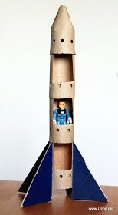 | SCIENCE-Moon Landings  Write down 5 or more fascinating facts about the history of moon landings.  .  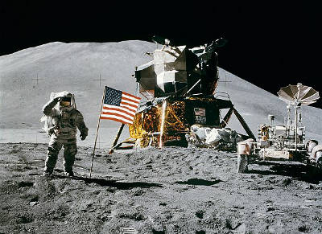 | Own Choice  You can come up with a homework task of your choice, as long as it demonstrates a skill or something new you’ve learnt. For example, baking, make a video of a new dance routine etc.

