August 2017 Week 2 Term 1
My Learning Week in Primary 6 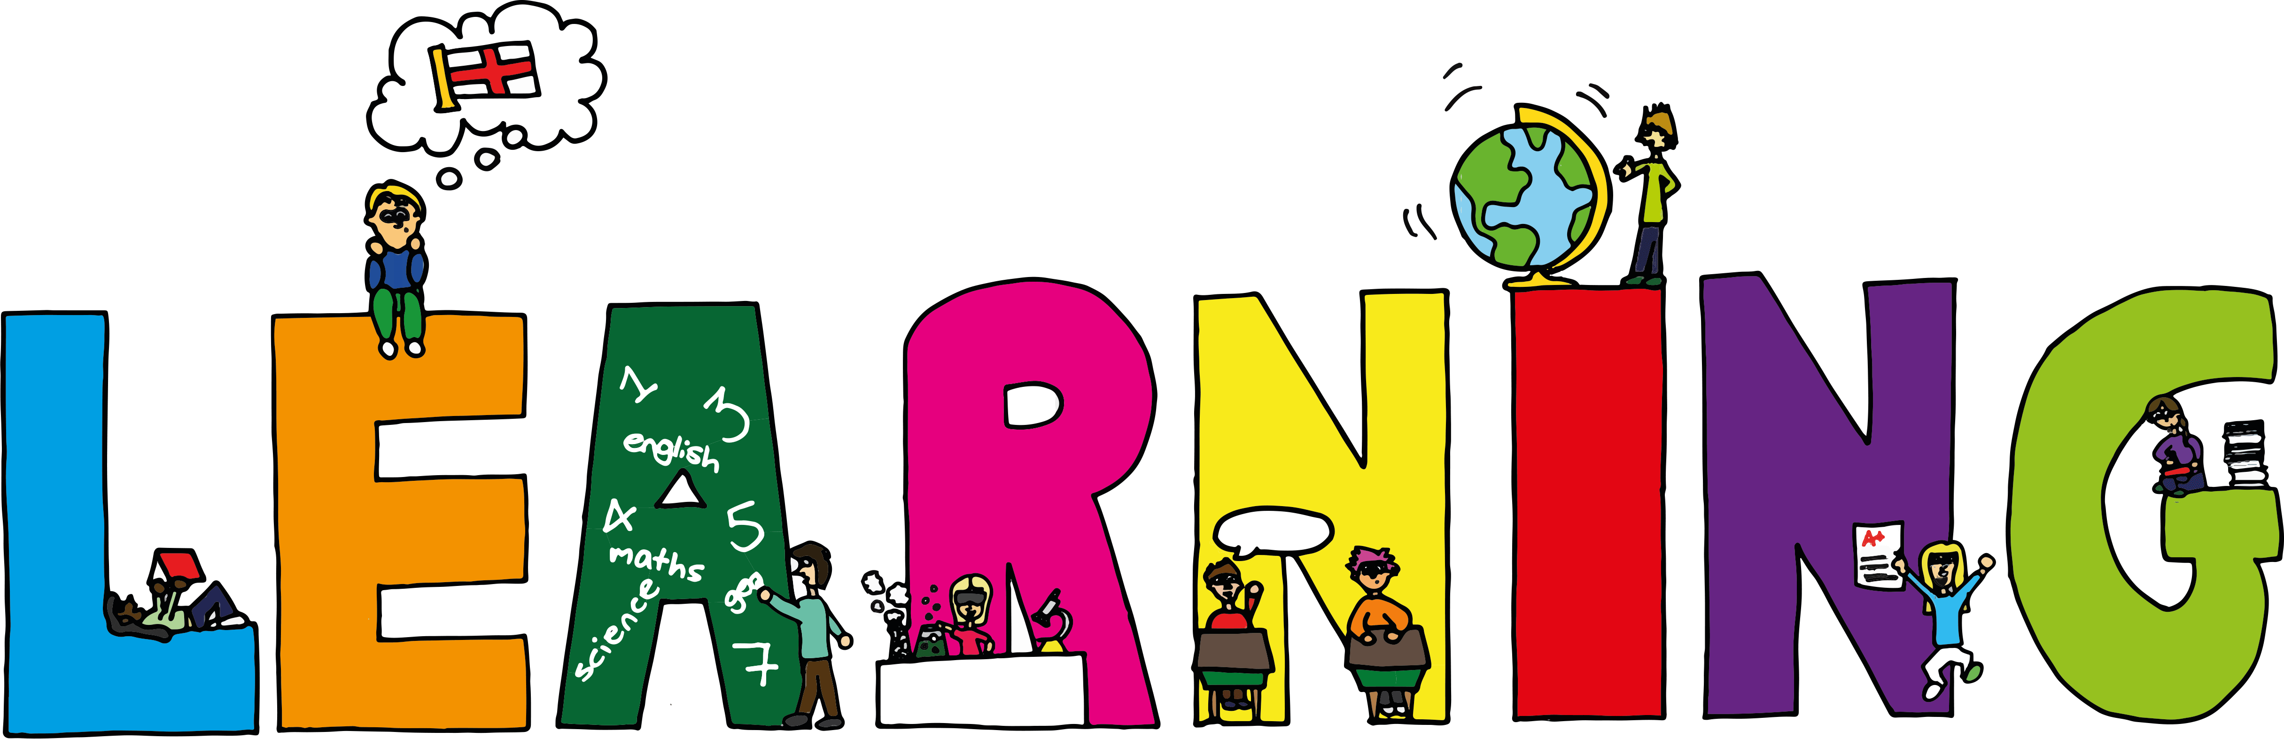
Literacy | Expressive Arts | Numeracy
Grammar  I can state the meaning of the parts of speech. (Nouns, Adjectives, Verbs, Adverbs, Pronouns and prepositions)  Handwriting  I can make my letters consistent in height and size  Poetry  I can write a poem, which describes the reader ‘all about me.’ | Google Name Logos  I can create a name logo that represents myself and my interests  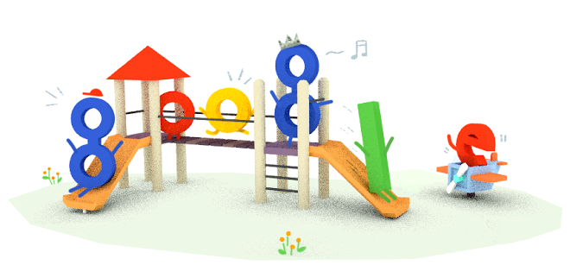  Self Portraits  I can sketch a self-portrait of myself using the right proportion by using guidelines as an aid. | Place Value  Read, write and say numbers (including decimals up to three places)  I can use my knowledge of place value to count, read, write, partition and order numbers
Health and Wellbeing | Health and Wellbeing-P.E | STEM
Growth Mind-set  I can state the difference between having a fixed mind-set, compared to a growth mind-set.  I can give examples of how I can use a growth mindset to help me achieve my goals.  Rights, Respecting Schools  I can explain what my rights and responsibilities areas a P6 student at Cramond Primary. | Possession Games  I can try my hardest learn new skills and techniques.  I can support others and show good sportsmanship. | I can explain what the acronym STEM stands for.  I can solve a problem by following the ‘Engineering Design Process’  ASK  IMAGINE  PLAN  CREATE  IMPROVE

