September 2017 Week 4 Term 1
My Learning Week in Primary 6 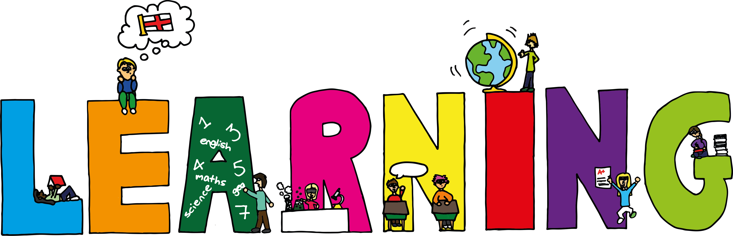
Literacy | Expressive Arts | Numeracy
Grammar/VCOP  I can state the meaning of the parts of speech. (Nouns)  Spelling  I can spell words which end in ask, ast and ass  Creative Writing  I can describe what it felt like to walk on a hire wire between the Twin Towers, including a range of Handwriting  I can practise writing letters, which have descenders. | Self Portraits  I can sketch a self-portrait of myself using the right proportion by using guidelines as an aid. | Place Value  Read, write and say numbers (including decimals up to three places)  I can round numbers to the nearest 10, 100, 1000 and beyond.  I can multiply and divide numbers by 10, 100 and 1000.
Reading
I can explain the strategies I can use to help me when I get stuck reading.
I can retell the main parts of the story I have read.
Science | Health and Wellbeing-P.E | STEM
Space…Our last chance for survival  I can work as a team and research facts about the planets in our solar system.  I can share my knowledge of space with others and ask questions | Possession Games  I can try my hardest learn new skills and techniques.  I can support others and show good sportsmanship. | I can design bridge out of newspaper that can hold as much weight as possible.  I can solve a problem by following the ‘Engineering Design Process’  ASK  IMAGINE  PLAN  CREATE  IMPROVE

