September 2017 Week 5 Term 1
My Learning Week in Primary 6 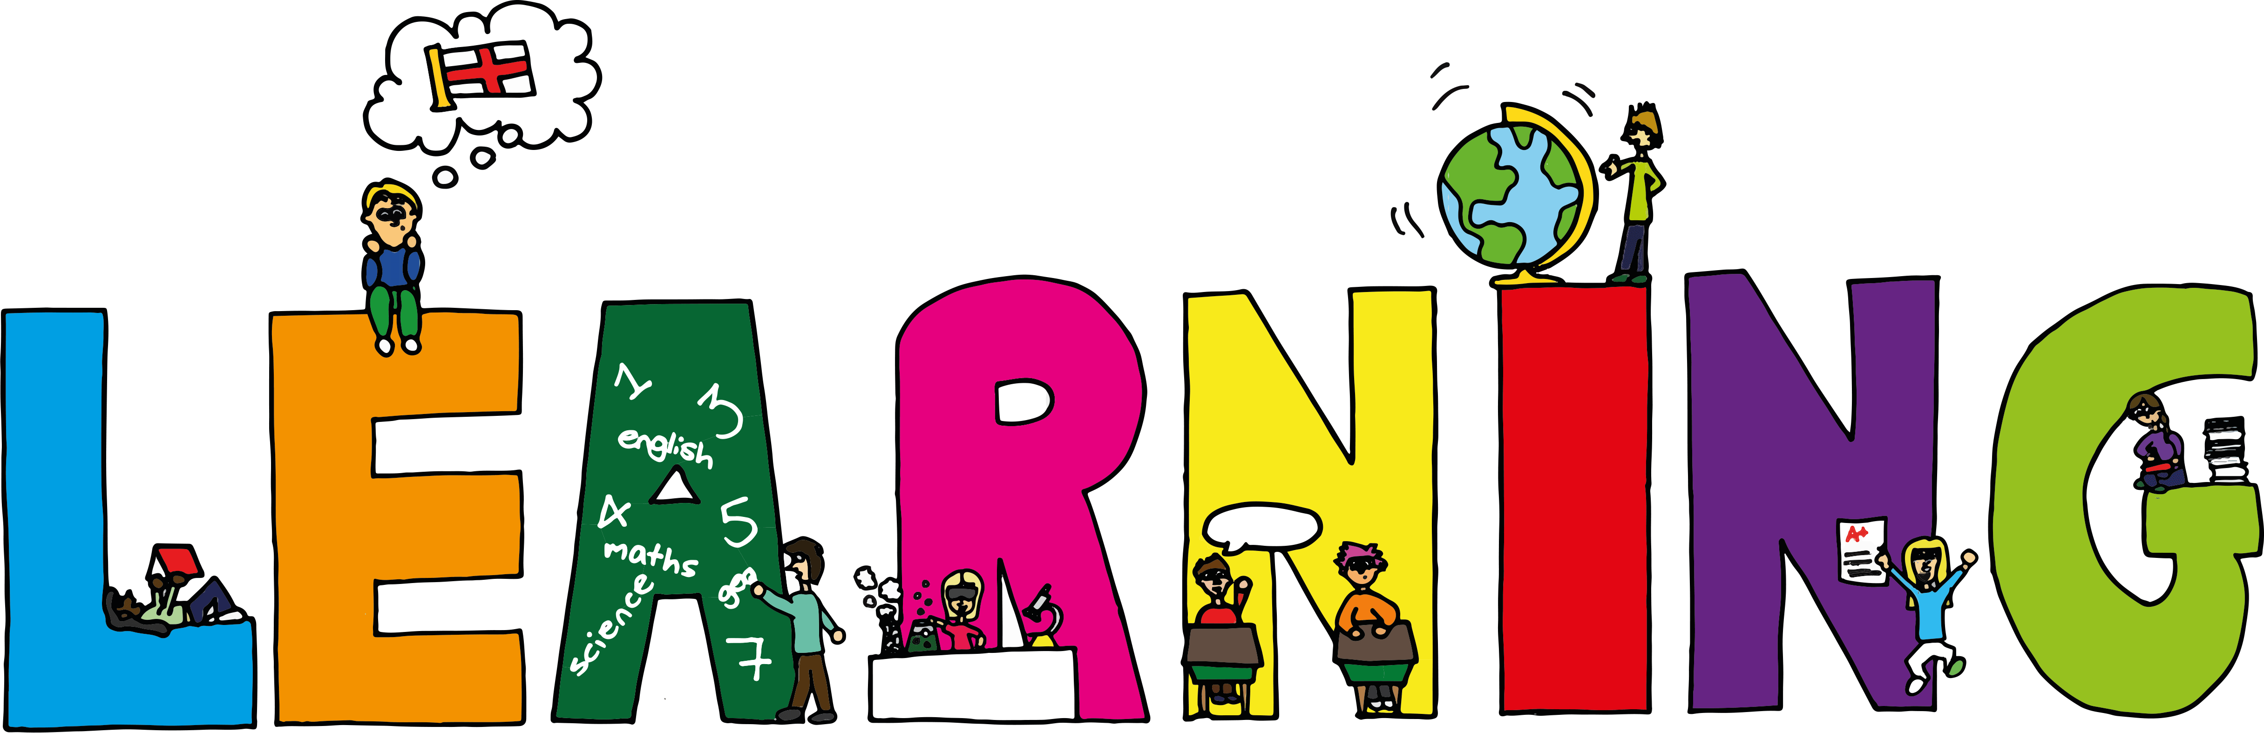
Literacy | Reading | Numeracy
Grammar/VCOP  I can state the meaning of the parts of speech. (Nouns)  Spelling  I can spell words which end in ask, ast and ass  Handwriting  I can practise joining from the letter o. | I can explain the strategies I can use to help me when I get stuck reading.  I can retell the main parts of the story I have read. | Place Value  I can multiply and divide numbers by 10, 100 and 1000.  I can multi step word problems by solving one step at a time.
Science | Health and Wellbeing-P.E | Health and Wellbeing
Space…Our last chance for survival  I can work as a team and research facts about the planets in our solar system.  I can share my knowledge of space with others and ask questions | Possession Games  I can try my hardest learn new skills and techniques.  I can support others and show good sportsmanship. | Cooperative Games  I can explain what it means to work ‘cooperatively’ with others.  I can work and play as part of a group in a cooperative manner

