September 2017 Week 6 Term 1
My Learning Week in Primary 6 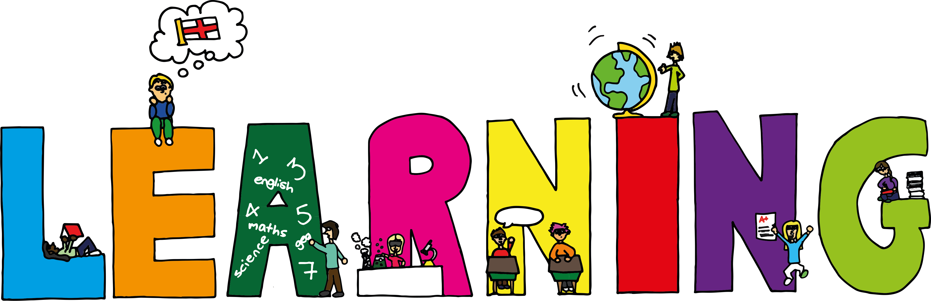
Literacy | Reading | Numeracy: Big maths
Grammar/VCOP  I can explain and find examples of adjectives.  Spelling  I can spell words which end in y  Handwriting  I can practise joining from the letter o. | I can explain the strategies I can use to help me when I get stuck reading.  I can retell the main parts of the story I have read. | It’s nothing new  I can add hundredths  Calculation  I can solve any 1dp + 1dp  Counting  I can read 6d numbers
Science | Health and Wellbeing-P.E | Health and Wellbeing
Space…Our last chance for survival  I can share my knowledge of space with others and ask questions.  I can make an informed decision on which planet our scientific team should colonise using the facts that I have learned. | Possession Games-Hockey  I can try my hardest learn new skills and techniques.  I can support others and show good sportsmanship.  I can pass, trap and control a hockey ball using the correct technique. | Cooperative Games  I can explain what it means to work ‘cooperatively’ with others.  I can work and play as part of a group in a cooperative manner  I can share my ideas and respectfully listen to others

