September 2017 Week 7 Term 1
My Learning Week in Primary 6 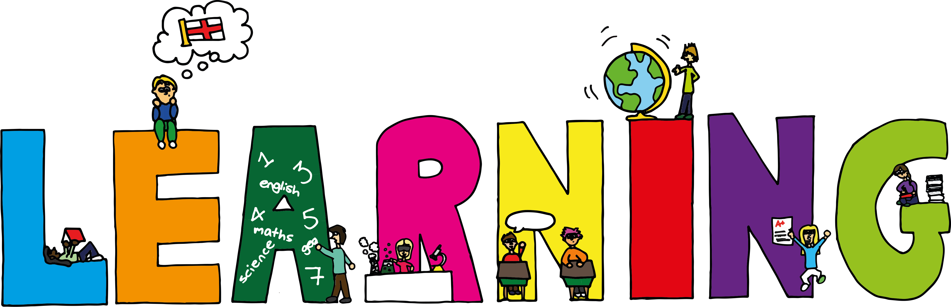
Literacy | Reading | Numeracy: Big maths
Spelling  I can spell words which end in y  Handwriting  I can practise joining from the letter o.  Persuasive Writing  I can explain and use different writing features authors use to persuade their reader | I can explain the strategies I can use to help me when I get stuck reading.  I can retell the main parts of the story I have read. | It’s nothing new  I can add hundredths  I can find the missing decimal piece  Calculation  I can solve subtraction problems involving money using a number line  Counting  I name the place and value of 2dp numbers
Science | Health and Wellbeing-P.E | Health and Wellbeing
Space…Our last chance for survival  I can share my knowledge of space with others and ask questions.  I can design and draw a spacecraft capable to travelling to Mars.  I can identify the risks of travelling to Mars and select a crew with the necessary skills to accomplish their mission. | Possession Games-Rugby  I can try my hardest learn new skills and techniques.  I can support others and show good sportsmanship.  I can pass and catch a rugby ball using the correct technique. | Cooperative Games  I can explain what it means to work ‘cooperatively’ with others.  I can work and play as part of a group in a cooperative manner  I can share my ideas and respectfully listen to others

