Snow Day Activities (P4)
We hope you are enjoying your snow days Primary 4’s. If you are looking for something to keep you busy, you could have a go at some of the tasks below.
Outdoor Learning  Have a go at building an igloo or a snowman. Take a photo and share it with the class when you return to school. Give your snowman a name and personality, or tell the class all about who would live in your igloo.  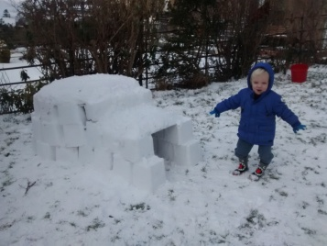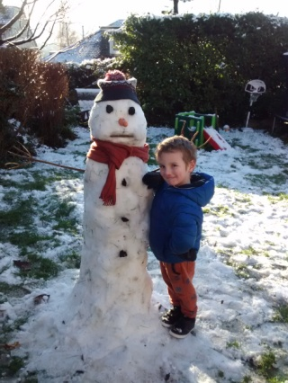  Note: use a plastic box to help you with your igloo blocks. | Literacy  Write a newspaper article all about the Beast from the East. You could do it on an iPad, laptop or by hand. You could then share it with your class when you return.  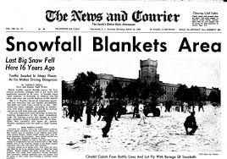 | Maths  Seen as we are focusing on measuring in maths at the moment. Try estimating different depths of snow and then take exact measurements using a tape measure. Explain why you think the snow is deeper in some areas and not others.  